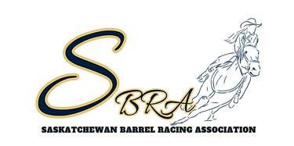

SASKATCHEWAN BARREL RACING ASSOCIATION
TENDER FOR 2025 FINALS ANNOUNCER

The 2025 SBRA Finals are scheduled on August 11-15, 2025, in Moose Jaw, SK at the Moose Jaw Exhibition Grounds. We require an announcer for 2.5-3 days (pending schedule and entries). The applicant should expect to announce around 400 runs (pending entries) for the long go days and roughly 200 on short go day.
The duties of this position are (but not limited to):
-Announce all runs throughout the competition days
-Provide music throughout the day
-Give sponsor shoutouts (can be prerecorded or live)
-Moose Jaw Exhibition supplies microphone and speaker set up
Your tender must include:
-Name
-Contact Info
-Any costs you charge the association for the week
-If you require hotel rooms for the week
-Any previous experience
Tender applications are due January 5, 2025.
If you have any questions, feel free to contact Amanda Porter at 306-434-5770. Tender applications must be submitted to saskbarrelracing@gmail.com.

