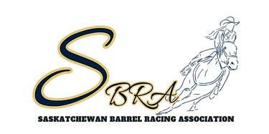

SASKATCHEWAN BARREL RACING ASSOCIATION
TENDER FOR 2025 FINALS PHOTOGRAPHER

The 2025 SBRA Finals are scheduled on August 11-15, 2025, in Moose Jaw, SK at the Moose Jaw Exhibition Grounds. We require a photographer for 2.5-3 days (pending schedule and entries). The photographer should expect to photograph around 400 runs (pending entries) for the long go days and roughly 200 on short go day. We also require our photographer to take our award photos following the short go.
Our Finals are held indoors so the photographer must have any of the appropriate equipment they will need to capture the runs. The SBRA will have a table setup by the arena entrance for computer set up for contestants to view and purchase photos (if that is needed by photographer). We will supply the photographer with a copy of the draw prior to the event.
Your tender must include:
-Name
-Contact Info
-Fees for photo purchase
-Any costs you charge the association for the week
-If you require hotel rooms for the week
-Some photo examples for the Board to review
Tender applications are due January 5, 2025.
If you have any questions, feel free to contact Amanda Porter at 306-434-5770. Tender applications must be submitted to saskbarrelracing@gmail.com.

