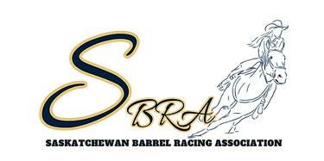

SASKATCHEWAN BARREL RACING ASSOCIATION
TENDER FOR 2025 FINALS GROUNDS PERSON

The 2025 SBRA Finals are scheduled on August 11-15, 2025, in Moose Jaw, SK at the Moose Jaw Exhibition Grounds. We require a Grounds Person for 3.5 days of competition and 1-2 days prior to event for ground prep (pending schedule and entries). The applicant should expect around 400 runs (pending entries) for the long go days and roughly 200 on short go day.
The duties for the position include (but are not limited to):
-Tractors and drags will be supplied (if there is an option that you prefer to bring your own equipment include that in your tender)
-Will rake after every 5 runs on paper (big rakes at every 50 runs)
-Must be there prior to the event starting each day to have ground prepped and ready
-Must be there for the day of time Onlies to rake and keep an eye on ground conditions
-Must be there on the Sunday morning at the latest to start prepping ground in case there is a need for removal or addition of dirt.
-If you are the applicant you are required to be in the facility while the Finals are running
*Moose Jaw Exhibition is willing to supply a driver for the second tractor that has previous experience at our Finals as well. If you will need a second driver supplied include that in your tender, if you are supplying your own second driver also let us know that*
Your tender must include:
-Name
-Contact Info
-Any costs you charge the association for the week
-If you require hotel rooms for the week
-Any previous experience
Tender applications are due January 5, 2025.
If you have any questions, feel free to contact Amanda Porter at 306-434-5770. Tender applications must be submitted to saskbarrelracing@gmail.com.

